THE FRUGAL YANKEE’S GUIDE TO
BEGINNERS’

BOOK DESIGN
MISTEAKS
MISTAKES

THE FRUGAL YANKEE’S GUIDE TO
BEGINNERS’
BOOK DESIGN
MISTEAKS
MISTAKES

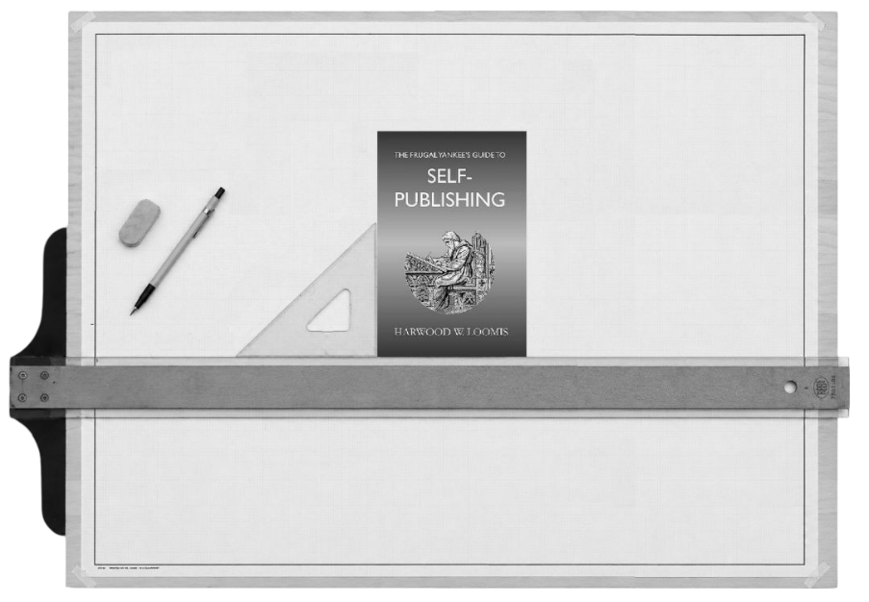

HARWOOD W. LOOMIS

The Frugal Yankee’s Guide To
Beginners’ Book Design Mistakes

Copyright © 2026 by Harwood W. Loomis.

All rights reserved.

No part of this book may be reproduced or transmitted in any form or by any means, electronic or mechanical, including photocopying, scanning, recording, or by any information storage and retrieval system without written permission from the publisher except in the case of brief quotations embodied in critical articles and reviews.

NO AI TRAINING: Without in any way limiting the author’s and publisher’s exclusive rights under copyright, any use of this publication to “train” generative artificial intelligence (AI) technologies to generate text is expressly prohibited. The author reserves all rights to license uses of this work for generative AI training and development of machine learning language models.

ISBN: 978-1-957418-23-0 (Paperback Edition)
ISBN: 978-1-957418-24-7 (Kindle Edition)


Published by:
THE ELDERSLIE PRESS
172 Peck Hill Road
Woodbridge, Connecticut 06525
United States of America

DEDICATION
Ideally, I would dedicate this book to whomever it was that first piqued my interest in book design and desktop publishing. Regrettably, if there was any one person or two people responsible, I have long since forgotten how, when, and where it happened. Instead, I dedicate this book to all self-published authors who bravely undertake the journey to designing their own books for print. It is a journey that becomes easier with every step.

They should make new ways to better design buildings and books. The computer was the end of Swiss typography!
— Emil Ruder

CONTENTS
DEDICATION v
CONTENTS ix
PREFACE xi
ACKNOWLEDGMENTS xv
PART 1 1
1 • FRONT MATTER 3
HALF TITLE PAGE 4
FRONTISPIECE 6
TITLE PAGE 6
COPYRIGHT PAGE 7
DEDICATION 8
EPIGRAPH 8
TABLE OF CONTENTS 9
LIST OF FIGURES 10
LIST OF TABLES 10
FOREWORD 11
PREFACE 12
ACKNOWLEDGEMENTS 13
INTRODUCTION 13
SECOND HALF TITLE PAGE 14
2 • BOOK BODY 17
PROLOGUE 18
BOOK BODY 18
FOOTNOTES & ENDNOTES 20
EPILOGUE 21

PREFACE
My introduction to desktop publishing and self-publishing preceded the advent of Amazon and print-on-demand publishing by several decades. My journey began in the 1980s, when I took over the editor’s job for a quarterly newsletter published by a not-for-profit organization. My predecessor as editor worked in the publicity department for a major corporation. He had access to professional typesetting equipment. Printing back then was strictly offset printing, requiring a photographic “plate” to be made of every page. My predecessor typeset and printed each article individually, then manually arranged the prints and pasted them onto master pages, which were sent to the printer.
I didn’t have access to any of the equipment needed to do that. I had heard of “desktop publishing” software. At the time, the major “name” computer programs for desktop publishing were Ventura Publisher, Aldus Pagemaker, and QuarkXpress. All three were professional-grade software and very expensive. I ended up buying a much less expensive British program that looked and worked somewhat like QuarkXPress but which had far fewer bells and whistles. For producing an eight page, black-and-white newsletter that came out four times a year, it was more than adequate.
Midway through my tenure as editor of the newsletter, a member of the organization’s board of directors approached me with a request. She was elderly. Her older brother had written a book, which he had given to an agent, but the brother had died before the agent could find a publisher who might be interested in the book. The agent had returned his copy of the manuscript to the sister, who decided along with the brother’s widow and a niece to self-publish the book as a memorial to the deceased brother. None of the three women knew anything about publishing, or even how to turn on a computer, so they asked if I could help.
In the mid-1980s, “self-publishing” consisted of generating a camera-ready copy of the book (produced by whatever means necessary) and then sending that off to a “vanity press” publisher, who would print as many copies of the book as you ordered and ship them to you in boxes. That was the only service they provided. I reluctantly agreed to take on the task of taking the book from a box of single, typewritten pages to camera-ready copy that could be sent to a vanity press publisher for printing. In order to do this, I had to educate myself on book design and organization, things which as a voracious reader I had always taken for granted. I eventually learned enough to produce the book, which was published. I have two copies of the final book on my bookshelf as a memorial to my initiation into self-publishing.
Self-publishing has changed dramatically since the 1980s. The invention of print-on-demand publishing has revolutionized the concept of self-publishing. It has made it possible for anyone and everyone to become a published author. Self-publishing no longer requires spending any money whatsoever. It no longer requires buying boxes of books and selling them out of your garage or your basement. The problem is that it has become so easy to publish your own books that many authors complete a manuscript and then rush into publication without taking the time and investing the effort to make their books look like … well, like books. A quick look at the “Look inside” preview of far too many books for sale on Amazon too often reveals tell-tale mistakes that instantly let anyone know that the book was produced by an amateur who didn’t have a clue how to set up a book for print. As a result, many prospective buyers simply move on to the next book.
I have written three books explaining how to use three different word processing programs (Microsoft Word, LibreOffice Writer, and FreeOffice TextMaker) to format books for print. This book isn’t another in a series of how-to books. Rather, this book is intended to be a general look at the aspects and details that distinguish a well-designed book from an amateurish disaster. Wherever possible, I will also point out common mistakes of first-time self-publishers, and discuss some of the traps rookies may fall into.
My goal in compiling the information in this book is to help first-time and new self-published authors to even the playing field, to help them learn how to assemble their books so they look professional enough that prospective buyers will judge their books by the content rather than based on an unprofessional appearance. Anyone who follows the suggestions provided by this book can easily design their own books for print-on-demand and have them look as good (or nearly so) as most books from major publishing houses.

ACKNOWLEDGMENTS
Judith C. Fettig, who worked for a number of years as a professional graphic artist in a commercial publishing house, was kind enough to review a draft of this book. I was pleased that, overall, she thought the manuscript covers the topic adequately. Her editorial comments were to the point and are greatly appreciated.
Abigail Damke is the daughter of a good friend and another pro-fessional graphic artist. Abby also agreed to look over the preliminary draft and to offer her feedback. Having had two practicing professionals look over my work goes a long way toward relieving my feelings of imposter syndrome in writing this book and presuming to advise other self-published authors on how to make their books look more polished.
Spyros Georgilidakis contributed the basic graphic I used as the basis for the cover, as well as feedback on this cover design. I could not have done the cover without his assistance.

THE FRUGAL YANKEE’S GUIDE TO
BEGINNERS’
BOOK DESIGN
MISTEAKS
MISTAKES

PART 1
THE PARTS OF A BOOK

1 • FRONT MATTER
A key decision facing all self-publishers is what to include in a book. Obviously, the essence of any book is the book’s body (the story, for fiction, and the subject matter, for non-fiction). Beyond that, though, there are several parts that make up a complete book. Some are optional and some are mandatory (or nearly so). One of the things that distinguishes a professional-appearing book from an obvious amateur creation is the presence or absence of these supporting parts—as well as their order of appearance and their content.
In very general terms, a book is broken down into three major components: the front matter, the book body, and the back matter—and many books do not contain any back matter.
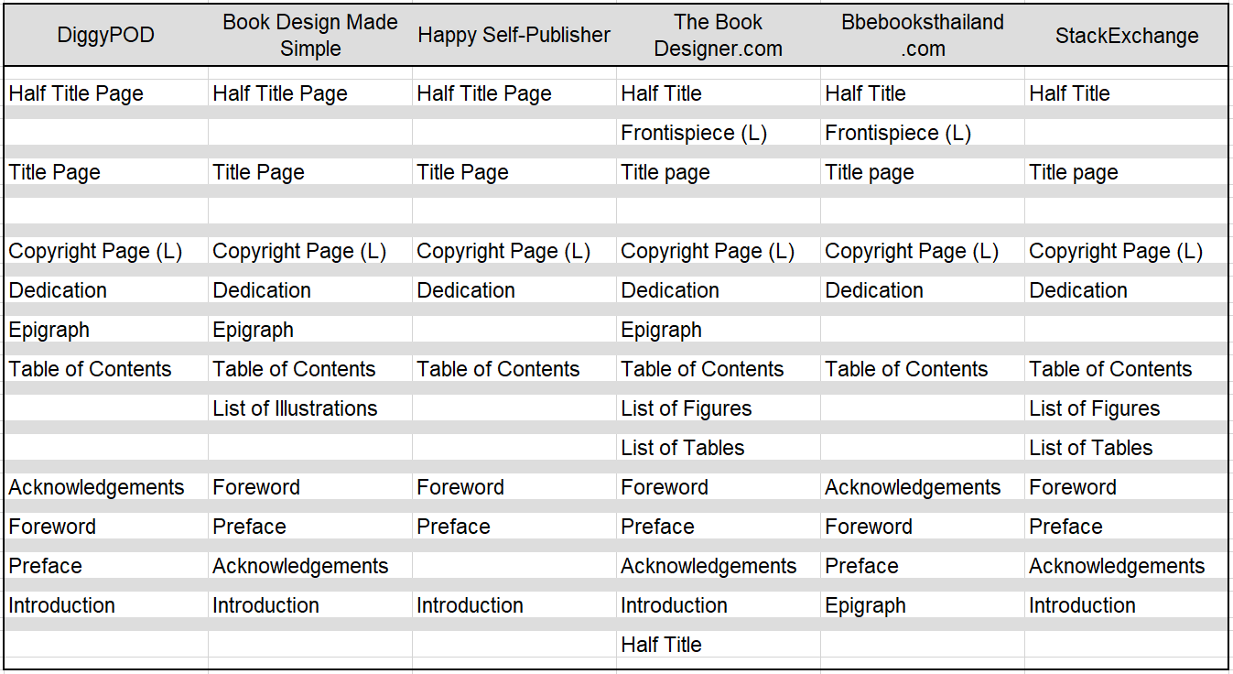
All books, however, contain front matter. At least, they should contain front matter. This chapter will discuss what the components of front matter are and how they should be organized.
Even “experts” don’t agree on the order or sequence in which the parts comprising front matter should occur in a book. The chart on the preceding page shows how six different sources suggest organizing them. They don’t agree on the order, and some of them include parts that others don’t even mention. I’ll discuss them in the order used by The Book Designer, since that offers the most complete tabulation.
Page numbering: Some pages in the front matter should display page numbers, some pages should not. Where page numbers are displayed on front matter pages, the page numbers should always be in lower case Roman numerals (e.g. i, ii, vi). Page numbering changes to Arabic numerals (e.g. 1, 2, 6) for the body of the book, and the page numbering is reset to “1” for the first page of the book body.

HALF TITLE PAGE
Status: Optional
A half title page is exactly what the name implies: it is a half-size (approximately) copy of the title portion of the title page, but including only the title itself, not the author’s name or the publisher. It may even omit any subtitle.
A half title page is not used in digital books, and is optional (but recommended) in printed books. It serves two purposes:
- It acts as a “sacrificial” introductory first page, to protect the actual title page from damage
- It provides a clean, open space inside the front cover for the author to inscribe and sign personalized copies of the book.
The text of a half title page should use the same typeface and layout in which the title appears on the full title page (which should also match the typeface and layout used on the front cover), but set in a type size that is approximately half the size used on the title page.
If used, a half title page should always be a right-hand page—the very first page inside the front cover. A half title page should not display any header, footer, or page number.

FRONTISPIECE
Status: Optional
A frontispiece is a page containing an illustration that sets the tone for a book and is almost always placed (if used) on the first left-hand page, facing the title page. If the book includes a half title page, the frontispiece will be the reverse side of the half title page. This means that if your book layout doesn’t include either a first half title page or a blank first page, there will not be a left-hand page facing the title page and you can’t use a frontispiece illustration.
The use of a frontispiece is always optional. There is especially no reason for it in an e-book.
If used, a frontispiece should not display any header, footer, or page number.

TITLE PAGE
Status: Mandatory
While a half title page is optional, the actual title page is not optional. The title page includes the full title of the book, the author’s name, and may also include the name (and possibly the logo) of the publisher. The layout and type style of the title page usually mirrors that of the outer cover, but title pages usually don’t include the artwork (if the cover includes artwork). Unlike a half title page, on the title page the book title is not reduced in size or scale; both the title and the author’s name should appear at approximately the same size and layout as on the outer cover.
The title page is always a right-hand page. If there is a half title page, the title page will be the second right-hand page in the book. If there is no half title page or blank first page, the title page will be the first right-hand page.
A title page should not display any header, footer, or page number.

COPYRIGHT PAGE
Status: Mandatory
Especially if the book is copyrighted (and who publishes a book without a copyright?), the copyright page is not optional. This is the page on which the author (or other copyright owner, if applicable) states the copyright and the year in which the copyright was created. The copyright page is always the left-hand page immediately following the title page.
The copyright page is also where the publication information is placed. This includes the Library of Congress Control Number (LCCN), if you obtained one, the ISBN number, any legal disclaimers (such as, for example, something like, “This is a work of fiction. Any resemblance between the characters in this book and real persons, living or dead, is accidental and coincidental.”) The copyright page should also include the publisher’s full name, physical address, and (if applicable) mailing address. You may want to also include a web site address.
It is important to understand that any disclaimer you place on the copyright page is a legal statement. You put it there for the purpose of avoiding legal liability, such as for inadvertently libeling someone. If you can possibly afford it, it would be wise to have an attorney either draft or, at least, review the language of your disclaimer. If you can’t afford to use an attorney, take the time to review and copy the disclaimers of as many books in your genre as possible. Write down the exact language, or take photos for reference. Look at the disclaimers in books from larger publishing houses rather than from indie self-publishers. The big publishing houses will have had their disclaimers drafted by corporate lawyers, so those will be the best examples on which to base your disclaimer
With the rise of AI (Artificial Intelligence) there has been increasing discussion among authors and “indie” publishers about protecting work from “scraping” (copying) written works by giant AI companies for use in “training” their AI engines. I have no wish to carry on that debate in this book, but I should mention that some writers approve (or, at least, condone) this “scraping by AI companies, and other writers do not. Some sources on the Internet suggest adding a disclaimer to self-published books, expressly prohibiting the use of the book for “training” AI. Authors who wish to include such a disclaimer should put it on the copyright page.
A copyright page should always be a left-hand page—the reverse of the title page. A copyright page should not display any header, footer, or page number.

DEDICATION
Status: Optional
Not every book has a dedication. If you choose to dedicate your book to someone, all that’s needed is a simple paragraph, or even just one sentence. If used, a dedication goes on the right-hand page following and facing the copyright page. The page should be formatted the same as a first page of a chapter, with the word “Dedication” in the same font and the same position on the page as the titles or headings of new chapters in the body of the book.
If used, a dedication page should always be a right-hand page. If used, a dedication page would be the first page to display a page number. It would not display any header or footer, other than a page number in a footer.

EPIGRAPH
Status: Optional
An epigraph, if used, is a quotation that sets the tone for the book. An epigraph is optional. Some authors may choose to omit an epigraph in the front matter and, instead, place a brief epigraph at the beginning of each chapter. The choice is yours.
If I use an epigraph, I prefer to put it on the next right-hand page following the dedication. Some book designers, though, place the epigraph on the left-hand page preceding (facing) either the table of contents, or the first page of the book body.
An epigraph does not display a title; it is simply a quotation, followed by the name of the author of the quotation and (optionally) the year it first appeared or was first spoken. An epigraph, if used, should be placed approximately one-third to one-half of the way down the page.
If used, an epigraph page should not display any header or footer, other than a page number in a footer.

TABLE OF CONTENTS
Status: Optional
A table of contents is optional, for both print and digital formats and for both fiction and non-fiction works. For fiction in print, I don’t think a table of contents is at all necessary. Where a table of contents is called for is in non-fiction and technical books, in which a reader might want to be able to quickly find and open directly to a specific topic.
Depending on the structure of the book, a table of contents may list only chapters, or it may be broken down into chapters and then sections and sub-sections within chapters.
In a print book, of course, the table of contents will include page numbers. For e-books, rather than listing page numbers (which have no meaning in e-books), the listings should be hot links. This makes just one more reason for maintaining two separate copies of the manuscript, one for the print editions and another for the digital editions.
If a table of contents is used, for print the table of contents should always begin on a right-hand page. The first page of the table of contents should not display any header or footer, other than a page number in a footer. If a table of contents extends beyond one page, headers may be included as an option. If so, the headers would be formatted the same as in the body of the book.

LIST OF FIGURES
Status: Optional (Non-fiction); Not used (Fiction)
In publishing, “figures” refers to illustrations. These may be photographs, drawings, sketches, maps—any sort of graphic image. They may or may not include captions. If a book includes a large number of illustrations, it can be helpful to include a list of figures following the table of contents. If you do so, the list should include the figure number, a descriptive title (if the caption is too long), and for print books it should include the page number. For e-books, the listings should be hot links.
A list of figures would generally be used for technical books such as text books or user manuals, in which readers may need to refer to a specific illustration. A book such as a general history book, in which a few illustrations are included solely as supplements to the text rather than specifically as instructive material, would not need a list of figures.
If a list of figures is used, for print the list of figures should be on a separate page following the table of contents, but it can be a left-hand page or a right-hand page. The first page of the list of figures should not display any header or footer, other than a page number in a footer. If a list of figures extends beyond one page, headers may be included as an option. If so, the headers would be formatted the same as in the body of the book.

LIST OF TABLES
Status: Optional (Non-fiction); Not used (Fiction)
Most books won’t include many tables, so a list of tables usually won’t be necessary. If your book does happen to include a large number of tables, it may be helpful to readers to include a list of tables that’s separate from the table of contents and the list if figures. If you include a list of tables, it should be set up the same as the list of figures.
If a list of tables is used, for print the list of tables should be on a separate page following the table of contents or (if used) the list of figures. The first page of a list of tables can be a left-hand page or a right-hand page. When a book includes both a list of figures and a list of tables and both are short, they can be combined onto the same page.
The first page of the list of tables should not display any header or footer, other than a page number in a footer. If a list of tables extends beyond one page, headers may be included as an option. If so, the headers would be formatted the same as in the body of the book

FOREWORD
Status: Optional
A foreword is a short essay written about the book by someone other than the author. A foreword is optional, and is more commonly used for non-fiction books rather than for fiction. If used, a foreword should be brief—typically one page, and not more than two pages. If used, a foreword should end with the name of the person who wrote it, the date, and the place of residence of the person who wrote the foreword.
As a rule, a foreword should be written by a recognized authority in the field covered by the book, and it should explain why the contents of the book will be of value to the reader in expanding their understanding of the topic or the field. Because the time of recognized experts in any technical field is valuable, unless you are an expert who has other experts as close, personal friends, it is customary for writers of forewords to be paid. The amount of the payment is a function of the fame and reputation of the author of the foreword, your own reputation in the field, the length of the foreword, and the value the foreword is likely to add to the book. A typical range might be between $100 and $500; do not blithely reach out to the world’s foremost expert in your topic and expect that he or she will be overjoyed to write a foreword for you—an unknown in the field—out of the goodness of their heart.
If used, a foreword should always begin a right-hand page. The first page of a foreword should not display any header or footer, other than a page number in a footer. If the foreword continues beyond one page, the continuation pages should display headers formatted the same as the body of the book.

PREFACE
Status: Optional
A preface is similar to a foreword, except that a preface is written by the author of the book. Like the foreword, a preface is optional. A preface is typically found in non-fiction books rather than in novels.
(Note: “preface” is pronounced in both American and British English as PREH’-fiss, not as PREE’-face.)
Authors may use a preface to explain how the book came into being: where they got the idea to write it, the reasons for writing it, the author’s qualifications in the subject matter of the book, and perhaps a brief discussion of any research methodologies employed in compiling the material that comprises the book. Also like a foreword, a preface should be brief—one or two pages, at most.
If you include a preface, use it to tell readers why they should read your book. Use the preface to share your excitement about the subject matter, and let them know what they’ll gain by reading your book.
If used, a preface should always begin a right-hand page. The first page of a preface should not display any header or footer, other than a page number in a footer. If the preface continues beyond one page, the continuation pages should display headers formatted the same as the body of the book.

ACKNOWLEDGEMENTS
Status: Optional
Most authors consult with someone during the course of writing a book, either for research into matters the author doesn’t fully understand, or editors and “beta” readers who helped review and polish the manuscript into its final form. The acknowledgements section is where the author lets readers know who helped him/her, and how, and where the author expresses thanks to those people.
From a book design perspective, including an acknowledgements section is strictly optional and it’s never wrong to omit it. From a perspective of personal ethics, my experience has been that it’s unusual for an author to complete a book with no help, input, or advice from anyone and it seems rude to not recognize people who helped you.
If used, an acknowledgements section should always begin a right-hand page. The first page of acknowledgements should not display any header or footer, other than a page number in a footer. If the acknowledgements continue beyond one page, the continuation pages should display headers formatted the same as the body of the book.

INTRODUCTION
Status: Optional
An introduction is usually used in non-fiction books. The introduction can be used to inform the reader about how the book is organized, and what are the purposes and goals of the book. In teaching, instructors are advised to begin a class by explaining to the students what they are going to learn, then go on to teach the material, and then to end the class by reminding the students what they have just learned. The introduction to a book serves the same purpose as the first of the three parts of teaching: use the introduction to “tee up” the material, to prepare your readers for the more detailed information that will follow in the individual chapters.
How is the introduction different from the preface? The preface should be about you, the author, and the process of creating the book. The introduction is about the subject matter of the book. It’s essentially a chapter before the first chapter, which is why it is part of the front matter rather than part of the book body. (Some book designers do, in fact, place the introduction after the front matter, as the first part of the book body.)
If used, an Introduction should always begin a right-hand page. The first page of an introduction should not display any header or footer, other than a page number in a footer. If the introduction continue beyond one page, the continuation pages should display headers formatted the same as the body of the book.

SECOND HALF TITLE PAGE
Status: Optional
A second half title page is an exact duplicate of the first half title page. Customarily, if half title pages are used at all, there are always two: one at the start of the front matter, and one at the very end of the front matter, to separate the front matter from the body of the book.
When used, a second half title page should not display any header, footer, or page number.
If half title pages are not used and the last page of the front matter is a left-hand page, the book body can start immediately, on the facing right-hand page, or a completely blank (on both sides) page can be inserted between the front matter and the book body. If the last page of the front matter is a right-hand page, the book body can begin on the next right-hand page if half title pages are not used.

2 • BOOK BODY
The main part of the book body is, of course, the story (for fiction) or the material comprising the subject matter of the book (for non-fiction). In addition to this, there may be other things that are still considered part of the book body: a prologue, footnotes, and an epilogue. All of these are optional; many books don’t contain any of them. In addition, some book designers treat introductions as the first part of the book body rather than as a section of the front matter.
In the book body, and on some pages of the front matter and back matter, the second and following pages of each chapter (or section) usually displays headers according to one of two basic schemes:
- In scheme 1, the left page header displays the author’s name and the right page header displays the title of the book. The page number can be incorporated into the headers, or page numbers can be placed in the footer. This is the header scheme almost universally used for fiction books.
- In scheme 2, the left page header displays the title of the book, and the right page header displays the title of the current chapter. As with scheme 1, the page number can be incorporated into the headers, or page numbers can be placed in the footer. This header scheme is often used for non-fiction books, text books, and technical manuals.

PROLOGUE
Status: Optional
Whereas an introduction is usually found in non-fiction books, fiction books often include a prologue to set the stage for the events that will take place in the body of the book. A prologue is the author’s opportunity to relate the back story that’s not part of the events in the book but which led up to the point in time where and when the book begins. In some cases, the prologue may also be a place to introduce one or two of the main characters—or it may be set far enough in the past that it introduces instead the ancestors of the book’s main characters.
If used, a prologue should always begin on a right-hand page. It should not have any header or footer, other than a page number in the footer. If a prologue is used, the first page of the prologue will be where the page numbering changes from lower case Roman numerals to Arabic numerals, and the page numbering will be reset to “1.” Continuation pages of a prologue will display headers.

BOOK BODY
Status: Mandatory
The body of a book is the book. The body of a book is where the author conveys whatever it is the intention of the book to convey. All the rest—the cover, the front matter, the back matter—is secondary to the book body. The body is where readers will spend their time with the book, so the body of the book is the most important part to make look professional and easy to read.
With fiction, the book body almost always consists solely of words. In non-fiction books, there may also be figures (illustrations or photos), charts, tables, footnotes and/or endnotes. The interior design should be based on presenting the body of the book as favorably as possible; the format of front matter and back matter follows the design established by the book body.
Traditionally, for hardcover books and better quality trade paperbacks new chapters always begin on a right-hand page. If a preceding chapter ends on a right-hand page, the reverse side of that page is left completely blank (no header, no footer, no page number). In current usage, it has become somewhat common with novels to allow new chapters to begin on the next page following the end of the preceding chapter, whether that happens to be a left-hand page or a right-hand page. For non-fiction, it is still more or less standard for new chapters to always begin on a right-hand page.
My preference is to always start chapters on a right-hand page. It’s a subtle feature that suggests to readers that the book designer and publisher cared about the book to make that effort. I know one writer of fiction who takes this so seriously that he always writes his chapters to occupy six or eight pages. Always. This means his chapters always begin on a right-hand page, and he never has any blank left-hand pages. If a chapter ends on a right-hand page in his first draft—he edits that chapter until it doesn’t end on a right-hand page.
The first page of a new chapter should not display a header. If the book’s design incorporates page numbering into the headers, this can mean that chapter first pages also don’t display a page number. Some book designers place the page number for chapter first pages in a footer, even if page numbers are in the headers for continuation pages.
If the book’s design puts all page numbering in the footer, then chapter first pages always display the page number, but omit the header. There is no absolute “right” way to handle this. The important thing is just to be consistent throughout the book.

FOOTNOTES & ENDNOTES
Status: Optional
Footnotes and endnotes are almost never used in fiction. They are used either to add supplementary explanatory information that might be distracting if incorporated into the main body of the text or, more commonly (especially in academic writing) for citing the sources of quotations.
When a book includes citations that require attribution, or supplementary information that the author wants to include but which doesn’t fit well with the main flow of the text, a decision has to be made: footnotes, or endnotes? Footnotes, as the name implies, are placed at the bottom (the foot) of each page. Endnotes may be placed at the end of each chapter, or may be consolidated into a single list at following the end of the main body of the book. Which way to handle them is entirely the choice of the author and book designer.
As a general rule, footnotes are more readily accessible. The information in a footnote is right there, on the same page as the quoted or cited passage. On the other hand, if there are too many footnotes or the footnotes are lengthy, they may dominate the page and distract from the main body of the text. In such instances, endnotes are preferable. If the choice is to use endnotes, the author must then decide whether to place the endnotes at the end of each chapter, or to collect them all together following the end of the body of the book.
All the major word processing programs include the capability to insert footnotes and endnotes. My recommendation is to allow the software to use the default settings for these.

EPILOGUE
Status: Optional
As a prologue is used to convey information about a back story, events that transpired before the start of the main action that comprises the story, an epilogue is used when the author wants to provide a wrap-up, to inform readers of what happens some time after the conclusion of the main story. An epilogue is used only in fiction. A rough analog in non-fiction might be a chapter titled “Conclusions” or “Summary,” but this is an inexact comparison.
If used, an epilogue should be formatted exactly the same as a chapter in the main body of the book.

