as intended

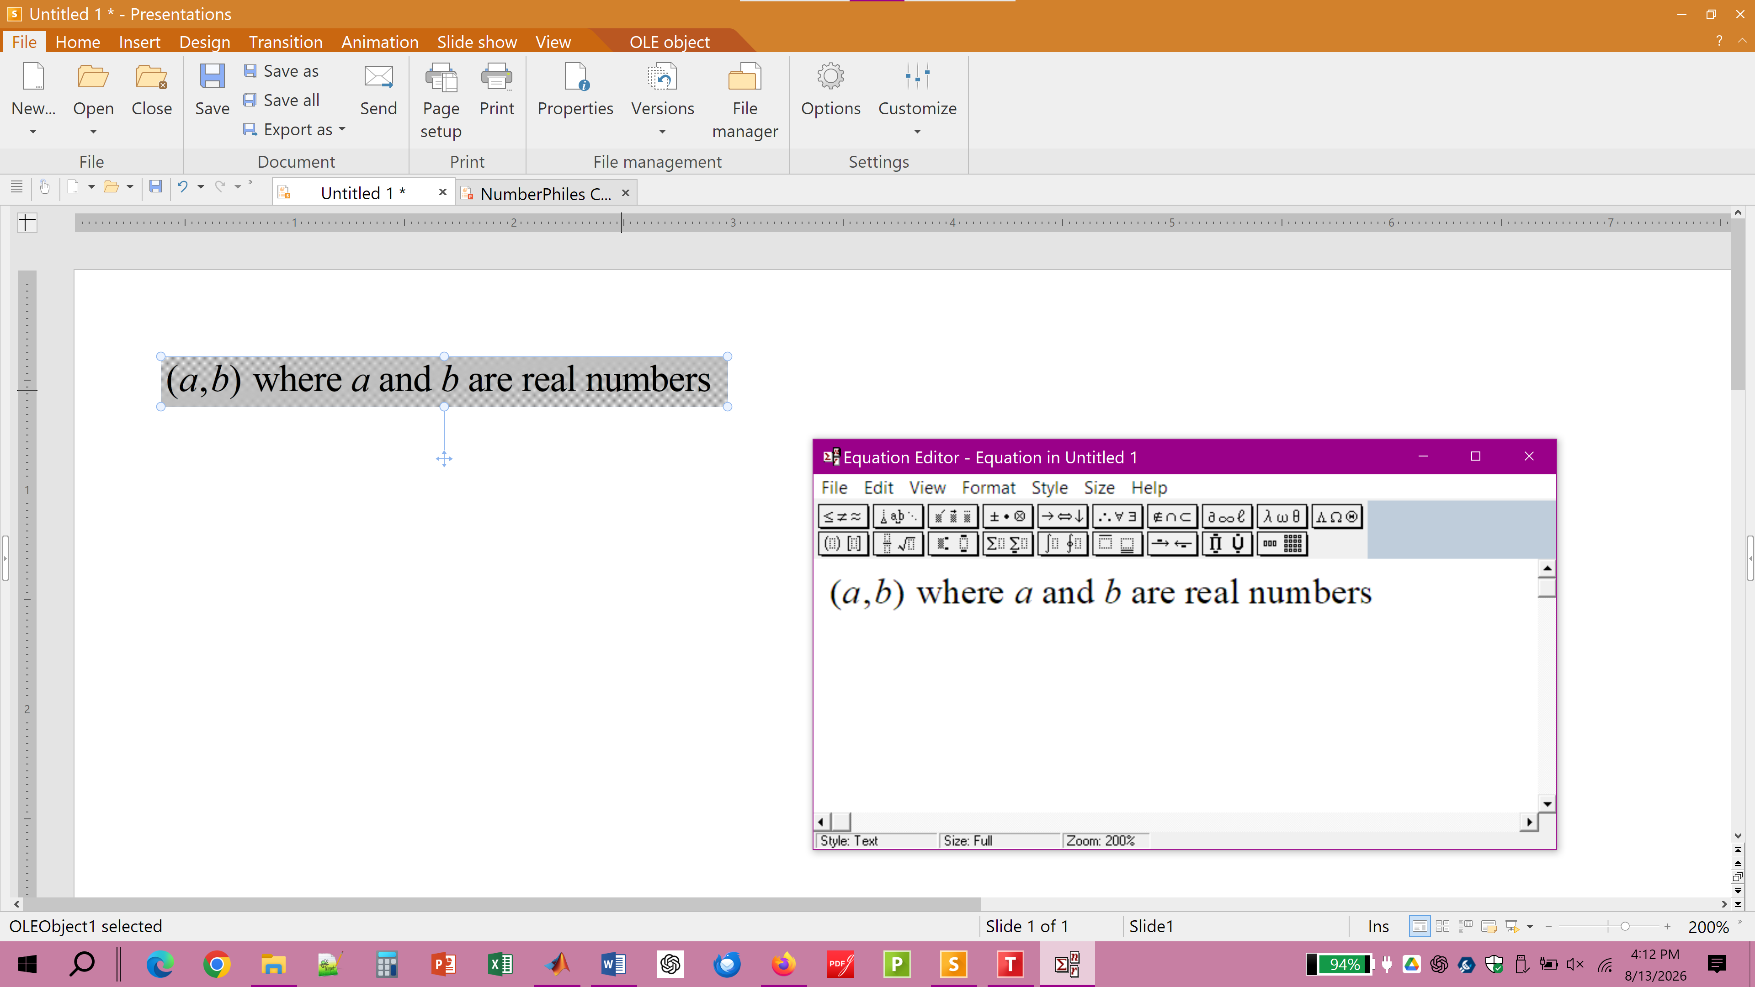

---------------------------------------------------------------------------------------------------------

after closing equation editor -- rendering is faulty, spacing is bad



