Suggestion: Add Formatting Options When Right-Clicking Selected Text
Purpose: For Quick Changes
Type: Similar to Options Displayed on the Ribbon
Possible Locations
- Add to Right-Click
- Add to the existing “Character Styles” section of the Sidebars.
- Make available on a Sidebar as its own section.

Examples from Various Wordprocessors

Softmaker Textmaker

Right-Click a Highlighted or Non-Highlighted Word (menu; not similar to Ribbon)
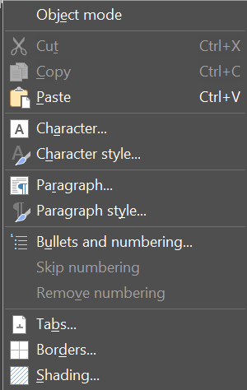

MobiSystems MobiDocs

Right-Click a Highlighted or Non-Highlighted Word (Ribbon on top, menu below).
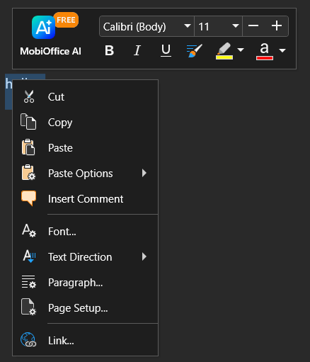

Crop of MobiDocs Right-Click (to add to top of Textmaker’s Right-Click)
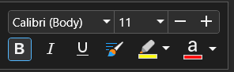

Microsoft Word

Double-Left Click (Ribbon options)
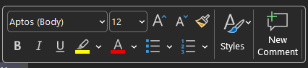

Right-Click (Ribbon on top, menu below)
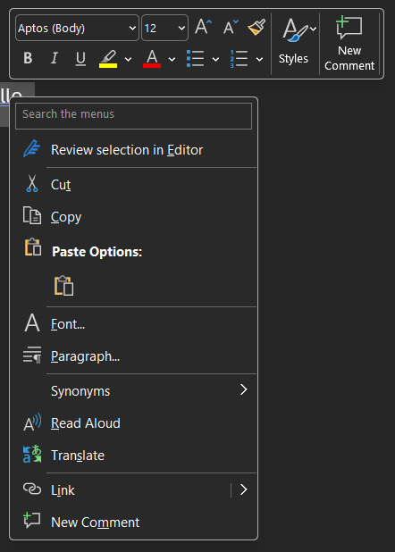

OnlyOffice

Right-Click (menu)
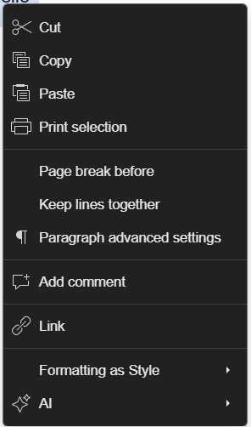

Collabora Office Desktop

Double Left-Click a non-highlighted word (Ribbon options).
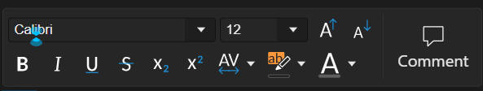

Right-Click a Non-Highlighted Word (menu)
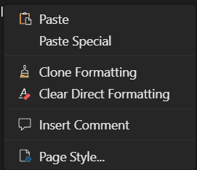

Right-Click a Highlighted Word (menu)
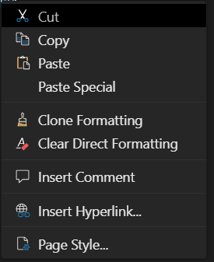

*Note that both the above panels are displayed at the same time if you double-left click and then right-click.

Right Sidebar in Collabora to optionally always display, independent of Ribbon Tab selected


