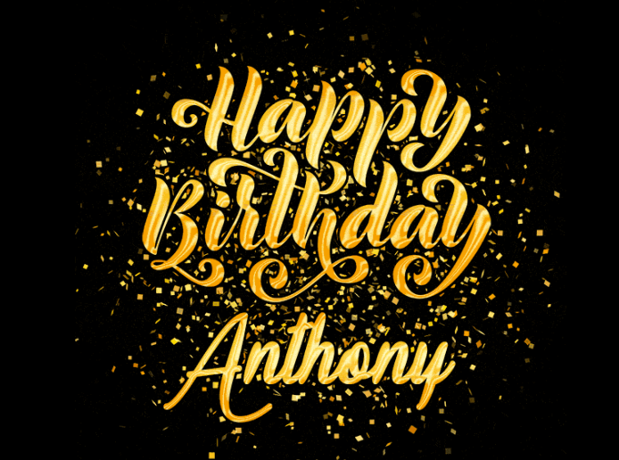
Hope that you have the greatest Birthday ever Anthony! I miss your impeccable insights on boxing, politics, and life! I am immensely honored and grateful for your friendship and loyalty all these years and in the years to come!

Your Friend and Brother For Always,

Jack

