A Short History of
ALL SAINTS' CHURCH LANDBEACH

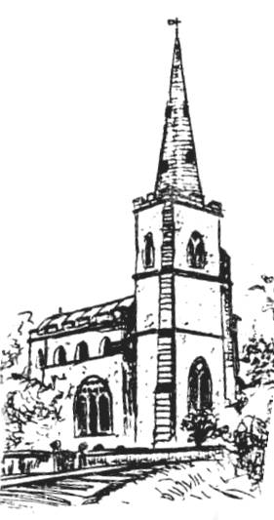
For centuries our parish church has provided the social and visual focus of Landbeach. In scale with the smallness of the village and set off by its slender Lincoln spire, it gives an elegant, well-proportioned finish to the village landscape.

Re-used Norman stonework has been un-covered in the walls, and so there has been a church on this site from at least the 11thcentury. The Chamberlayne family, Lords of the Manor next door, probably constructed the main part of the building as we see it now, although there was extensive rebuilding in the 14th and 15th centuries that incorporated some of the Early English structure of this previous church in the north and east walls of the chancel. The tower also was re-built and strengthened with its tall arch and buttresses to support the spire.

An outstanding feature and great ornament of the church is the 15th century nave roof. Nicholas Toftys, “carpenter of Landbeche” probably constructed it in about the year 1450. Four carved angels in feathered suits alternate with four robed benefactors to decorate the hammers between the tie beams, each bearing a painted shield. The angels’ wings are missing, although their mortices are present. The shields illustrate the history of the parish and were painted by Fanny, the wife of the Revd Bryan Walker, the Victorian Rector who carried out the restoration of 1885.

The main nave roof was later raised and its pitch altered to insert a clerestory, and lower pitched roofs were built to cover the wider aisles. The south porch was added to complete the whole, and a north porch was added in 2006 to provide disabled access, toilet, sink and a new heating system.

Later generations have, on the whole, confined their efforts to restoration, but in the 18th century the Revd Robert Masters pulled down the dilapidated Lady Chapel used as a school, on the north side of the chancel, in order to bring the then fashionable symmetry to the building. In the great restoration of 1878 the present organ vestry was built on the site of this former Lady Chapel. The organ was installed in 1906.

A good deal of mediaeval woodwork is incorporated in the benches, pulpit and screens. Much of this came from Jesus College Chapel, Cambridge. The Revd Robert Masters bought the woodwork that was being taken out of that chapel in 1787 when it was being re-furnished, to provide the pews and screens in our village church. In the Victorian restoration the 16th century pews from Jesus College were brought together in the south aisle.

The enormous iron bound parish chest with its two locks is one of the older pieces of woodwork in the church. It has a carrying handle at each end, although its great weight must have made it scarcely portable. There are two keyholes and locks, and from the style it is dated to about 1500. In the church inventory of 1613 this chest is recorded as ‘a great chest barred w^{th} Iron w^{th} ij lockes to keepe the bookes and lynnen.’

Two of the seats in the chancel are much older and are original to the early church. They have on their undersides in place of misereres the arms of Bishops l’Isle and Arundel, bishops of Ely in the 14th century when they were benefactors to this church.
A plaque by the chancel steps commemorates Matthew Parker, Rector of Landbeach 1545 - 1554 while Master of Corpus Christi College, Cambridge, and subsequently Archbishop of Canterbury under Elizabeth I.

The Revd Robert Masters acquired most of the mediaeval stained glass, and although the chief effect is the quality of colours, there is much interesting detail. He may have got the east window from Wimborne Minster in Dorset. The Madonna head in the centre of the window is said to be a portrait of the Lady Margaret, foundress of St John's and Christ's Colleges in Cambridge, and mother of King Henry VII. Figures on either side are supposed to represent her parents, John and Margaret Beaufort. These fragments of glass give only an inkling of the amount of colour that there was once in the church. So, too, do the remains of 14th century wall-painting behind the pulpit.

In the north aisle, just east of the north door, is what may be an Easter Sepulchre. This takes the form of a shallow recess under an arch. However, it was thought at one time to be a 13th century memorial to the founders of the present church, the Chamberlayne family. A tomb slab now placed by the tower arch probably dates from this period.

The font has a basin from Robert Masters’ time placed on top of a Victorian pedestal.
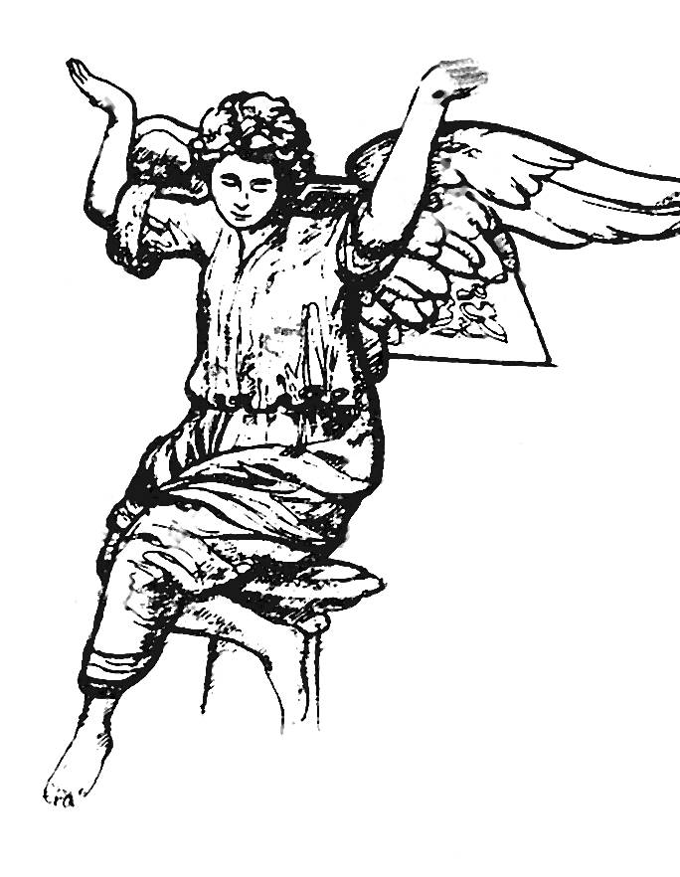
The wooden angel that forms the lectern originally came from a church in Holland. It was bought in York by the Revd Bryan Walker in 1882 and once formed part of a substantial 17th century pulpit structure of angels and St Michael and the dragon.

The latest additions to the church are two new bells installed in 2024. These enhance the original ring of four to six bells. The oldest of these, the tenor, dates from about 1510, and weighs over 11 cwt.

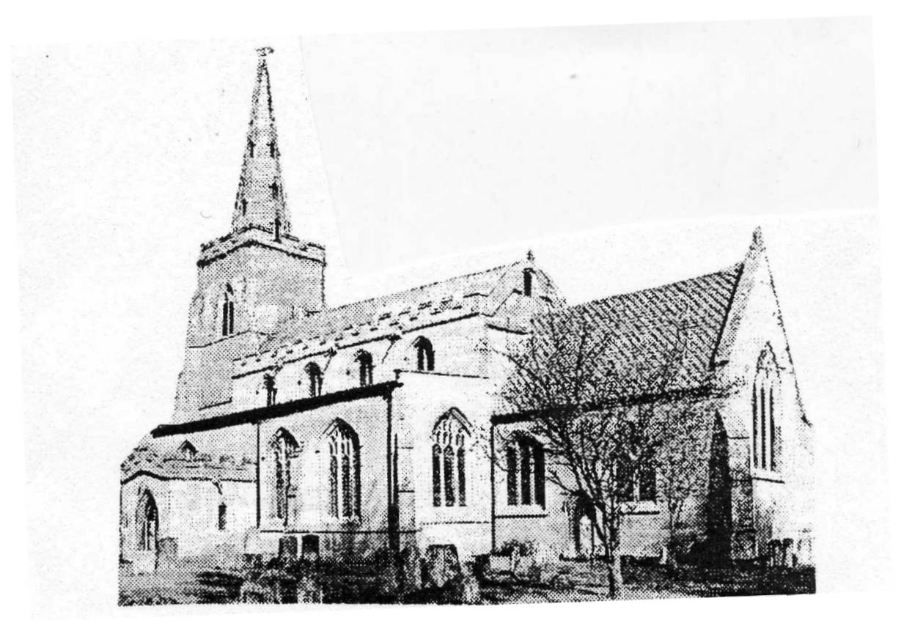

Text based on an original by Dr J. R. Ravensdale (Churchwarden 1971 - 1988) by Dr Ray Gambell (Reader 1979 - & Churchwarden 1988 -)

