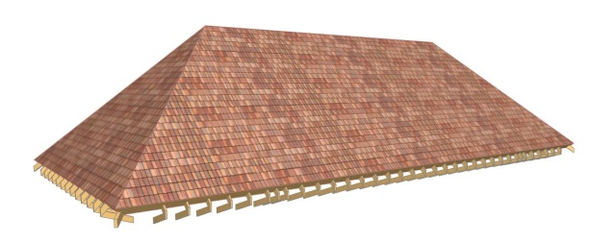

J T Roofing(Kent)Ltd
Specialist in all roofing finishes
4 Lime Court, Kennington, Ashford, TN24 9AB
Tel & Fax: 01233 620134
Mobile: 07887 803064
E-Mail: jtroofingkentltd@gmail.com
Invoice No: 2044
Date:28/09/2023

Customer Name
Jim Small
Customer Address:
Court Lodge sellindge
Job reference
New fibreglass roof
VAT Number 310 1892 40
Company number. 12152576
Utr number 8646815730
Barclays 20:54:25
73090906

