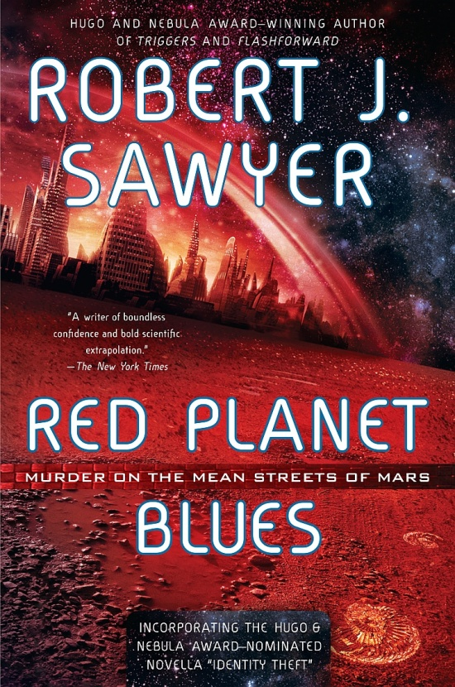

A one-hour TV series
based on the bestselling novel by
ROBERT J. SAWYER
The creator of FlashForward

Murder on the
Mean Streets of Mars

Red Planet Blues isn’t yet-another spaceship story. Think of it, instead, as The Maltese Falcon on Mars: a hard-boiled noir detective series set in the near future. Sure, science-fiction fans will like it—but so will mystery fans, adventure fans, and those who enjoy snappy dialog and larger-than-life characters. Red Planet Blues is gritty, sexy, and wise-ass tech noir, telling stories of lawless greed, adventure, and romance.

Alex Lomax, our main character, is the one and only private detective on Mars, a hard-boiled gumshoe in the classic Sam Spade mode. World-weary, cynical, and outwardly amoral but with a personal code of honor that he always adheres to, Alex is handsome, buff, and likes his scotch. He’s an underdog; trouble follows him everywhere. But he’ll always go to the mat for his clients—Alex has his own somewhat skewed moral compass in a lawless world filled with treachery, backstabbing, and double-crossing.

In this future, most people are still normal biological humans, but there is a process by which a person’s consciousness can be copied into a more durable—and more attractive!—android body. Bullets are useless against these transfers, as they’re called; in fact, only the recently developed broadband disruptor can fry a transfer, and there’s just one such prototype unit on all of Mars.

Biological humans leave behind DNA, fingerprints, blood splatters, and more. But transfers don’t; they let us tell real whodunit mystery stories in which it’s plausible that the perpetrator—or the victim!—isn’t immediately identified.
Although the quality of the body you transfer into depends on how much you’re willing to spend, for the most part these aren’t obviously mechanical creations. Transfer bodies are nearly indistinguishable from biological human ones, although some people, like Alex, are good at spotting the tells — an unnatural fluidity of movement, a certain sheen to the artificial skin when the light catches it just right. He calls it “paydar,” the ability to spot a bought android body. And what bodies they are! Who can resist upgrading their faces and physiques when transferring? Alex often comes up against spectacularly good-looking opponents.

Our principal setting is New Klondike, a domed frontier town built after fossils were discovered on Mars, triggering The Great Martian Fossil Rush. In an age in which gold and diamonds can be easily synthesized, owning actual evidence of extraterrestrial life is the new status symbol, and good specimens are worth millions—so stampeders came to the red planet, hoping to strike it rich. But the rush is now mostly over, and the boom town of New Klondike is falling into disrepair, giving us mean streets, abandoned spacecraft hulls, and a shantytown against which to tell our gritty noir mystery stories.

Most of our stories will take place under the dome, in a shirt-sleeve environment, but we will occasionally venture out onto the Martian surface. Although Alex will have to don a surface suit when doing so, those who have transferred need no such thing to walk about freely outside the dome. Both inside and out, we’ll play Mars’s gravity as it really is — just 38% of Earth’s — letting us stage spectacular barroom brawls and stunning out-on-the-surface fights.

RECURRING CHARACTERS

Conniving lowlifes, corrupt cops, adventurers, murderers, punks, and thugs: all the usual noir characters will be looking out for themselves on our version of the red planet.

Lakshmi Chatterjee: cunning and ruthless, she’s a novelist who, like Jack London coming to the real Klondike, has turned up on Mars seeking adventure, fame, and riches.

Diana Connolly: Owner of the Bent Chisel, the local saloon. In and around Alex’s intriguing mystery cases, we’ll follow their smoldering relationship—and Alex’s growing realization that Diana is much more than she seems to be.

Ernie Gargalian: If Mars has a Mr. Big, it’s Ernie—both literally and figuratively. Obese, with huge appetites, Ernie runs Ye Olde Fossil Shoppe, lining up collectors on Earth to buy the fossil bounty found by prospectors. He controls the black market for just about everything on Mars.


Reiko Takahashi: The owner of the NewYou franchise on Mars, where people can transfer their consciousness into android bodies. She’s the granddaughter of Denny O’Reilly, one of the original two prospectors who first found fossil riches on Mars.
Hungarian edition

Dr. Rory Pickover, the only idealist on Mars: a paleontologist who believes fossils should be preserved for science. Brilliant and bookish, our Rory is witty and urbane rather than nerdy.

Juan Santos, on the other hand, is a typical pencil-neck geek
— and Alex’s drinking buddy who consults with him on cases involving computers, robotics, and the science behind the transfers.

Detective Dougal “Mac” McCrae: The head of New Klondike’s small corporate police force; his job is tax collector/enforcer for the corporation that built the domed settlement. He tolerates Alex because he serves a purpose that Mac’s not interested in filling—providing justice—but Alex’s efforts often put them in head-to-head conflict.

FIRST-SEASON STORY ARCS

The pilot and the rest of the first season will adapt Robert J. Sawyer’s bestselling Red Planet Blues novel. The meat of the entire season is in the book, already worked out in exciting detail.

Alex Lomax is a wanted man back on Earth; he had to leave and can’t go back. The backstory of why is a mystery we’ll play out over our first season, letting us explore our lead character’s deepest, darkest secrets.

Alex will fall for Diana then lose her as he discovers she’s involved with somebody else—real Bogie-and-Bergman stuff. Later, Diana will be killed by Lakshmi—or so Alex will think, only to discover that the transfer who saves his ass out on the surface in a gunfight is really his Diana in an upgraded body. Her new artificial android body will give her super strength. At the end of the first season, she’ll join Alex as his new partner in the detective agency.

The Great Martian Fossil Rush began decades previously when two private-sector explorers, Denny O’Reilly and Simon Weingarten, stumbled upon the Alpha Deposit mother lode. But they died in an apparent accident, and the secret of the Alpha’s location died with them. The mad search by many parties, including Lakshmi Chatterjee and Martian kingpin Ernie Gargalian, to rediscover the mother lode drives much of the action and conflict.

THE PILOT

A woman hires Alex Lomax to find her missing husband, Joshua Wilkins, who recently struck it rich with fossils, transferred his consciousness into an android body—and disappeared. Meanwhile, paleontologist Rory Pickover is convinced that someone has made a duplicate copy of himself — a transfer created without destroying the original — and is extracting information from it, including maybe the location of the Alpha Deposit mother lode. He hires Alex to track down and eliminate the duplicate. Both cases are intertwined, leading to a showdown aboard the abandoned hulk of an old spaceliner. With Diana’s help, Alex struggles to find a just solution that will save not only his own hide but also that of the hapless duplicate of Pickover while bringing a ruthless killer to justice.

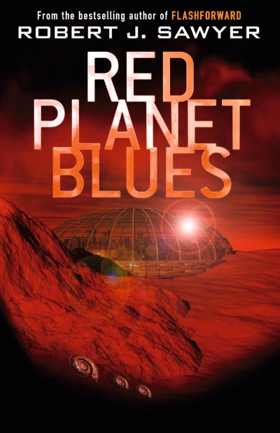
THE REST OF THE FIRST SEASON

A diary of the ill-fated final voyage to Mars made by Denny O’Reilly and Simon Weingarten is uncovered. Alex discovers that they were murdered, and the murderer may still be at large, with his sights now set on Denny’s granddaughter Reiko.

The duplicate Dr. Pickover transfer introduced in the pilot locates the Alpha Deposit only to find that somebody has booby-trapped it—meaning someone else knows where the mother lode is. He hires Alex to discover who that might be, before the priceless fossil beds are pillaged.
British edition

Alex’s prime suspect is novelist Lakshmi Chatterjee. While on the trail of the killer of Weingarten and O’Reilly, Alex discovers their long-lost buried landing craft, with its wise-cracking artificial intelligence Mudge still intact, the only witness to what went down all those years ago.

Meanwhile, the notorious death ship B. Traven—upon which a brutal series of murders took place—is returning to Mars, and three identical transfer thugs, illegal copies of the same person, seem to be picking up murdering in New Klondike where the shipboard killer left off.

Alex ends up tying all the threads together, but he’s heartbroken to see his beloved Diana killed by Lakshmi Chatterjee—only to discover in our season finale that, in reality, Diana framed Lakshmi and has survived, transferring into a new super-strong body.

SAMPLE EPISODES FROM LATER SEASONS

Although we’ll always have ongoing story arcs, the engine of Red Planet Blues is the case of the week involving Alex and Diana, who, after transferring, becomes Alex’s partner in the detective agency. They’ll deal with cases such as these:

Bless My Soul
An explosion rips through Reiko Takahashi’s NewYou franchise—someone has bombed it. Preacher Jono Dawson has been telling his ragtag flock that the whole notion of transference is predicated on a lie: souls can’t move from biological bodies into artificial ones. Since the biological original is normally destroyed after transference is completed, NewYou’s business is legalized murder, he says. When the police fail to find the bomber, Reiko hires Alex and Diana to track him down.

Biding Time
Who’d kill a sweet little old lady after she’d transferred into a near-indestructible android body—when it would have been so much easier to kill her before she’d done that? As Alex and Diana discover in this disturbing case: the woman’s son. He’d smothered his own sister when they were both children, but it had been assumed to be a case of crib death, and their mother had blamed herself for it. The son, now adult, had been biding his time, waiting for his mother to finally pass on so that he’d at last never again have to see the sadness in her face, never again hear her crying. But when she opted to be around forever, he couldn’t take it anymore ...

The Longest Night
Mars is prone to dust storms; sometimes, the whole planet is engulfed by them. A big one comes up, blanketing the entire New Klondike dome—and during this, someone steals a key component of the town’s power-generating facility, plunging the interior of the dome into darkness. As temperatures drop and the air grows stale, Alex and Diana struggle to track down the perpetrator, knowing they’ve got a better shot at finding him than the cops do. It’s a race against the clock set against rioting and looting as the whole town is plunged into blackness.

Brother, Can You Spare a Solar?
Someone is killing the homeless in New Klondike—a serial killer seems to be loose under the dome. When one of Alex’s longtime informants is murdered, he and Diana take up the case—and they uncover evidence that the corporation that built New Klondike is behind the crimes, eliminating the indigent who haven’t been paying their Life Support Tax. But if they blow the whistle, Alex will end up being shipped back to Earth, where he’ll face the murder charges he came to Mars to escape ...

BUILDING ON SUCCESS

- FlashForward, the previous adaptation of one of Robert J. Sawyer’s bestselling novels, was the fastest-selling TV series in Disney’s history to that point, bought by over 100 markets worldwide.

- Sawyer’s Red Planet Blues novel was a national mainstream bestseller in Canada, hitting #3 on the Maclean’s bestsellers’ list, #8 on the Globe and Mail bestsellers’ list, #2 on The Edmonton Journal bestsellers’ list, and #1 on both the Winnipeg Free Press and Saskatoon Star-Phoenix bestsellers’ lists. Sawyer novels have been translated into 21 languages worldwide.

THE TONE OF THE SERIES: Excerpts from Reviews of the Novel


“Alex Lomax is more layered than your standard-issue private eye, and whether you read it as a science-fiction story with a good mystery inside or as pulp mystery with a science-fiction setting, Red Planet Blues is a rollicking read, at turns funny, exciting, and full of twists and turns.” —Daytona Beach News-Sentinel

“A wonderful Raymond Chandler-meets-Ray Bradbury vibe permeates Red Planet Blues. Sawyer’s Mars is as realistically realized as his settings always are: from the shady dive bars to the sweeping Martian plains, he paints a vivid picture. But it’s his creation of Alex Lomax, the good-naturedly tarnished soul of the story, where Sawyer really shines: a hard-boiled noir detective on Mars—the character he was born to write.” —The Maine Edge (Bangor, Maine)
Chinese edition

“Red Planet Blues resurrects the noir mystery, the gold-rush western, and the science-fiction adventure. The result is a unique, fun story that manages to put a smile on your face in spite of the pulse-pumping action and adventure.” —Orson Scott Card’s InterGalactic Medicine Show
“A tour de force. Sawyer makes New Klondike as real as the street in front of your house. To top it off, he obviously had fun writing this book, and that sense of fun comes through on every page.” —Analog Science Fiction and Fact

“A highly original and fun homage to the great hard-boiled detectives of the past. Mars, like the sun-kissed streets of Los Angeles Philip Marlowe once patrolled, has just as many dark and dangerous secrets as anywhere else. You’ll have a lot of fun wandering the mean streets of New Klondike with P.I. Lomax, and he might even give you a few things to think about.”
—Seattle Post-Intelligencer

“Sawyer has an absolute ball playing with the mystery form. The result is a lively love poem to the mystery genre that is terrific fun.”— Sci Fi Magazine (Syfy Channel)

“Alex Lomax is a hard-boiled, borderline-shady private eye, living among corpses, gangsters, thugs, and crooks. That he sees himself as Humphrey Bogart would be obvious, even if he didn’t adorn his place with Bogie movie posters. Red Planet Blues is a total hoot; a humdinger of a read: it’s funny, it’s a terrific page-turner, and it moves faster than a rocket.” —Winnipeg Free Press

THE TEAM

Red Planet Blues is a joint project of writer Robert J. Sawyer and producer Robert Wertheimer. Rob Sawyer and Bob Wertheimer have worked together since 2002, when Bob brought Rob on to write the series bible for Charlie Jade, a Canada-South Africa co-production Bob co-created and produced. Both Rob (born in Ottawa) and Bob (born in Montreal) are dual US-Canadian citizens, free to work in either country.

ROBERT J. SAWYER

Robert J. Sawyer is one of only eight writers in history—and the only Canadian—to win all three of the world’s top Science Fiction awards for Best Novel of the Year: the Hugo, the Nebula, and the John W. Campbell Memorial Award.

In 2016, Rob was inducted into the Order of Canada, the highest honor bestowed by the Canadian government, and in 2017 he was inducted into the Order of Ontario, the highest honor bestowed by his home province; he was the first person ever to be inducted into either order for work in the science-fiction field.
Rob’s film and TV writing credits include produced primetime US network TV drama, two commissioned feature-film screenplays, and commissioned series pilots and series bibles. He wrote the series-finale episodes for the acclaimed web series Star Trek Continues.
A member of both the WGA and the WGC, Rob has written for ABC, the CBC, CTV, Copperheart, Harmony Gold, Nelvana, Shaftesbury, and gaming giant Ubisoft, among others.

Rob has worked creatively with major industry figures including Ron Bass, Brannon Braga, Fred Fuchs, Vince Gerardis, Scott M. Gimple, David S. Goyer, Michael Hirsh, Vincenzo Natali, Anne Cofell Saunders, Karl Schaefer, William Shatner, Douglas Trumbull, and Robert Halmi, Sr.

Nineteen of Rob’s bestselling novels have been optioned for film or television production. He is represented by Gersh. His website is sfwriter.com.

ROBERT WERTHEIMER

Robert Wertheimer is a writer, producer, director, and executive producer of film and television productions. He is the president of Jonsworth Productions.

After a long career making theatrical feature films (including Deepa Mehta’s Sam & Me, which was honored at the Cannes Film Festival, and box office champion Bollywood/Hollywood, also written and directed by Deepa Mehta) and television series (Friday the 13th: The Series; War of the Worlds; RoboCop: The Series; and Due South, for which he won a Gemini Award for Best Series), Bob made the choice to write and create his own material.

In 2004, his first television series as co-creator and showrunner, Charlie Jade, debuted. Lasting 21 episodes, it was produced in South Africa for CHUM in Canada, and broadcast in Canada on Space and the United States on Syfy.

Bob’s next creative effort was the television series Across the River to Motor City, which he co-created with Denis McGrath. Produced in partnership with Richard Mozer and David Devine of Devine Entertainment, Across the River to Motor City is an examination of two stages of one man’s life threaded through a mystery involving the conspiracy speculation surrounding the assassination of John F. Kennedy.

Bob was producer of Madcap Learning Systems, inventing non-linear teaching methods with Sir Ken Robinson (the most eminent education futurist on TED Talks) for The Bill & Melinda Gates Foundation. Currently, Bob is a partner with Saul Rubinek’s company in development on Another Shot, a half-hour comedy.

JOSEPH MALLOZZI

Joseph Mallozzi is a Canadian writer, showrunner, and producer with over 25 years experience in the television industry. He has over 350 hours of produced television to his credit in addition to 100+ hours as both a writer and a showrunner. He has worked primarily in the genre field, most notably on the Stargate franchise (Stargate SG-1, Stargate Atlantis, Stargate Universe), Dark Matter (a show he created and showran for three seasons), and Hulu’s Utopia Falls.

CAL COONS

Cal Coons is an award-winning writer/director/showrunner. His credits include the hugely popular series Murdoch Mysteries, Frankie Drake Mysteries (both of which he also developed for television) and Hudson and Rex. He co-created Blue Murder. Other credits include Remedy, The Listener, Republic of Doyle, Good Witch, and ReGenesis. He’s worked closely with broadcasters and distributors such as CBC, CTV, Global, Rogers TV, Hallmark, Discovery, ITV, UKTV, Alibi, and Fox International.

