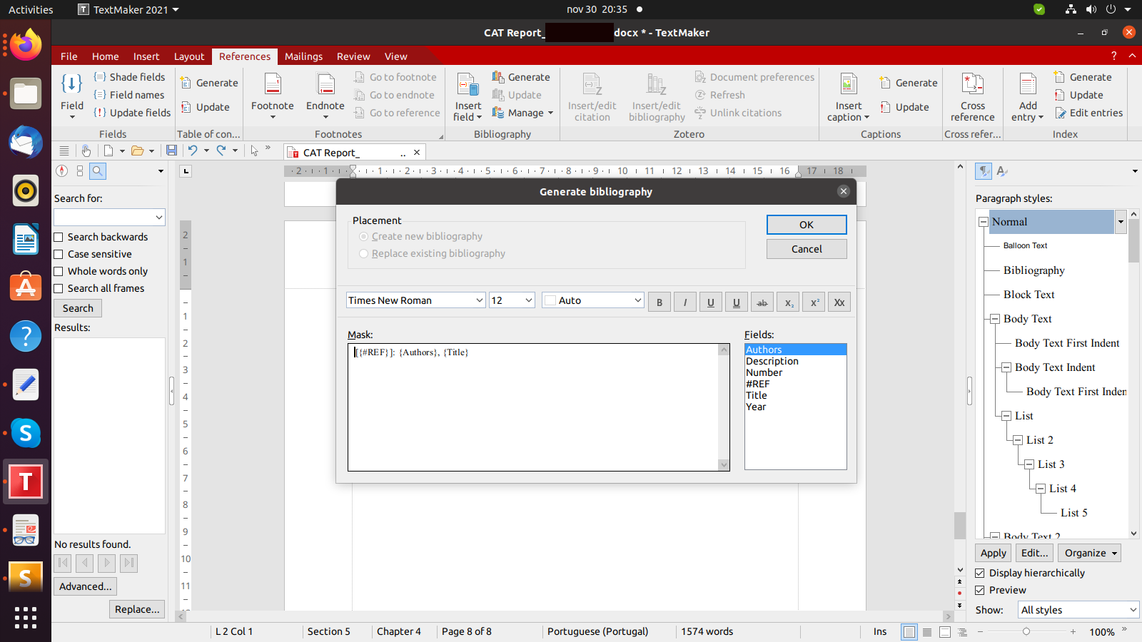
Sample text that references a Figure 1 and then next picture in sequence is unexpectedly the bottom right image Figure 2, instead of the Figure 3 (bottom left image). The user has little control over how the images are numbered.
Figure 1 - Sample Screenshot

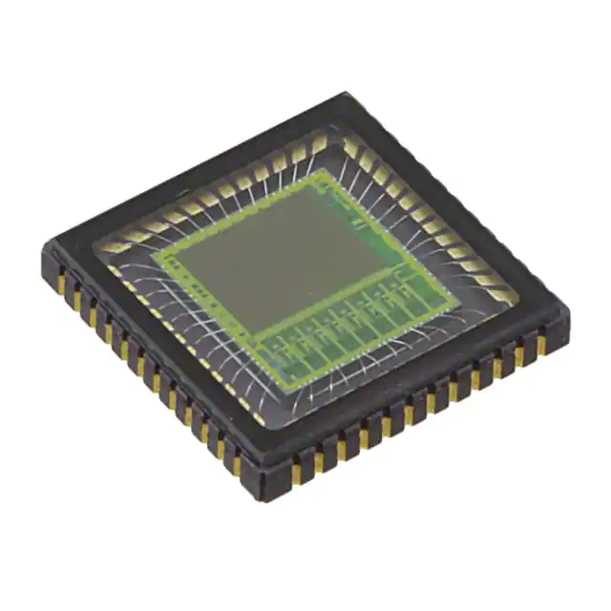
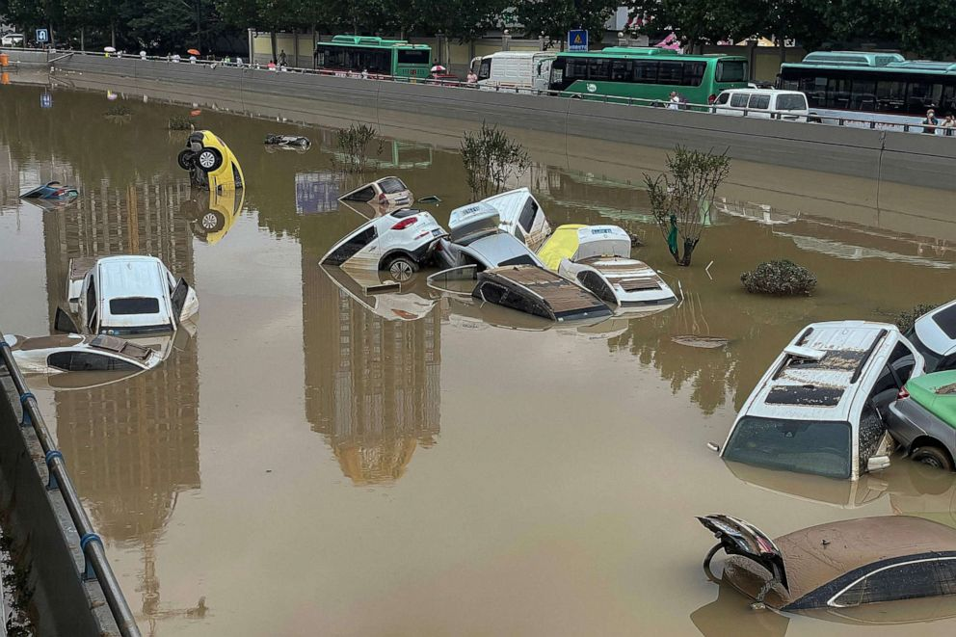
Figure 3 An image sensor chip
Figure 2 Flood in a highway

