Trying to work with tables
Insert tables, trying to have numbered rows, formatting the rows (paragraph before and after nos of pts) and inserting new rows after formatting
Situation 1: Insert tables, trying to have numbered rows,
Steps:
1. Insert table 3 columns and a few rows
2. Highlight left column
3. Press “Toggle Numbering”
4. Result is as shown above, the number 1 repeats itself for each row.

Solution:
1. Go to Toggle Number after it appears as above
2. Go to Format Number
3. Select “Numbered List” and Click on “New”
4. Select your choice of numbered list styles and then click OK.

Question: Can we not have it easier, so by highlighting the column, and clicking on the “toggle numbering” function instead of number 1s in all rows it would be sequential numbers.

Situation 2: paragraph spacing format of the rows changes or reverts to old spacing when inserting new rows

 | Row as para spaced (Amended Row Spacing)
 | New row inserted, para spaced reverts to | Amended Row Spacing
 | Amended Row Spacing
 | Amended Row Spacing
 | Insert new row
 | Amended Row Spacing
Steps
1. Set paragraph spacing as shown in the screenshot below.
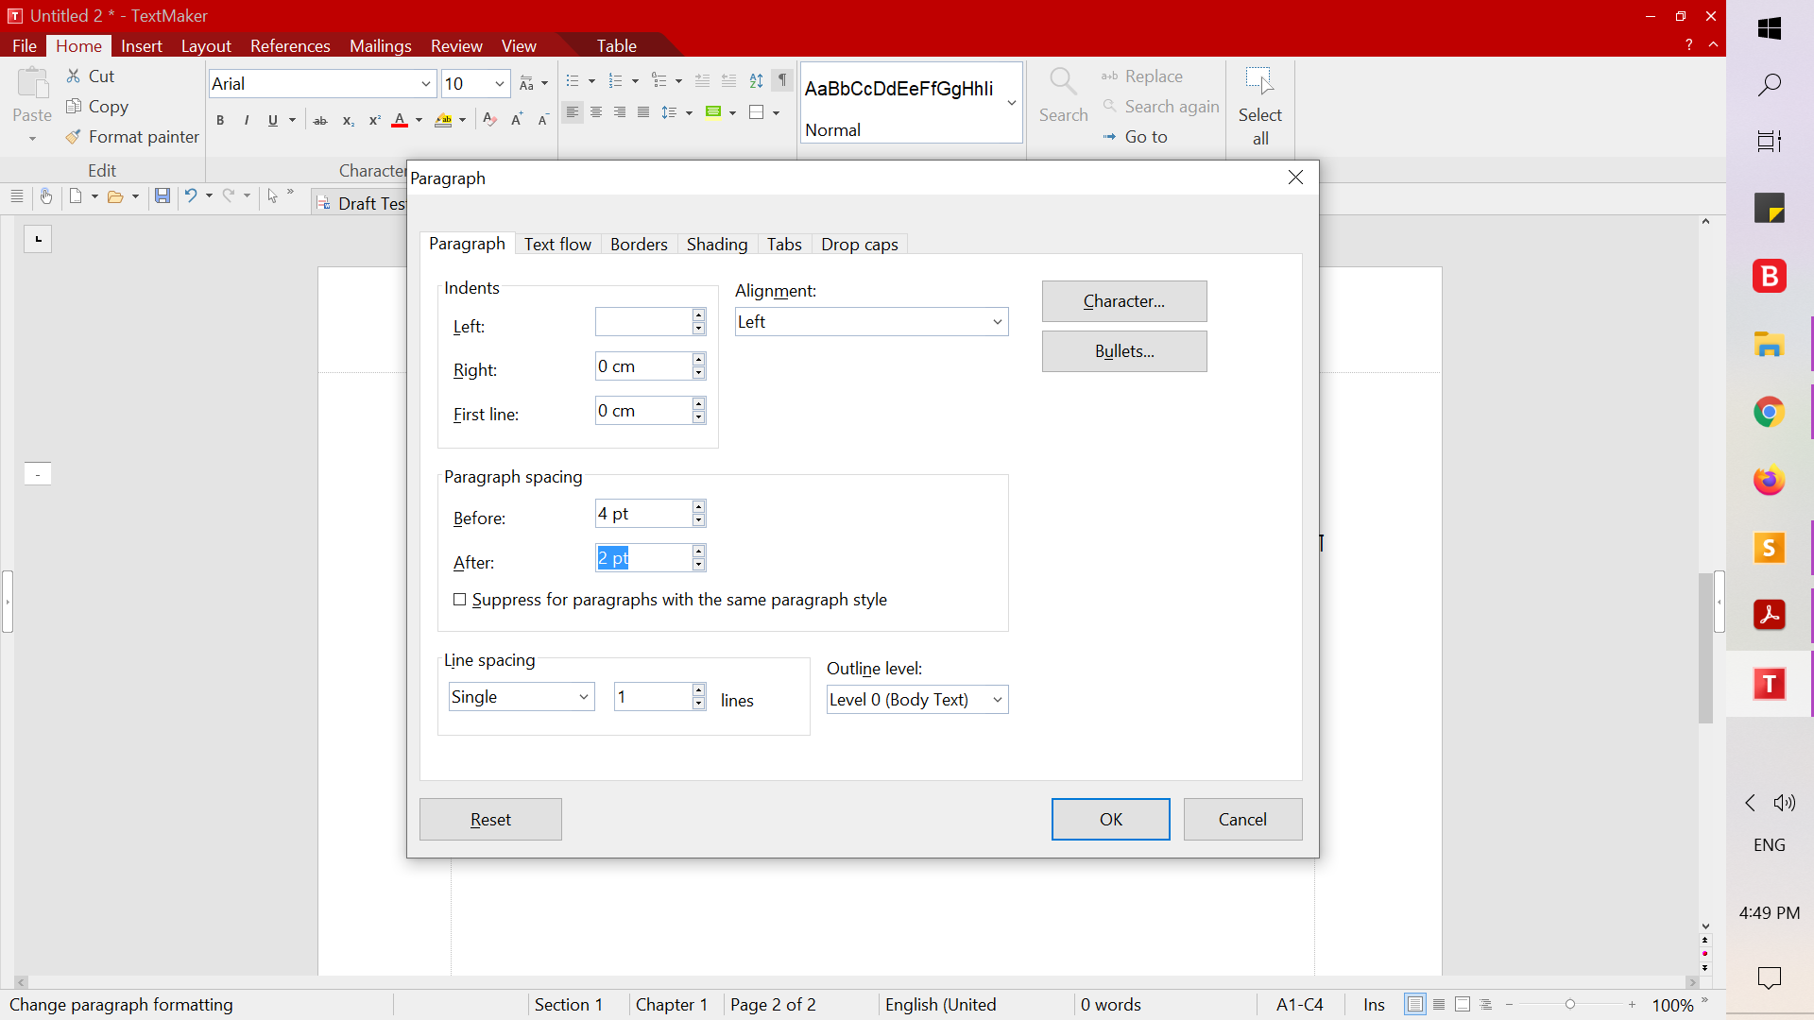
2. The table above shows the paragraph spacing formatted.
3. New row inserted - and that causes no numbers to be inserted, and 2nd column changed the para spacing, see screen shot. Para Spacing before and after shows 0 pts
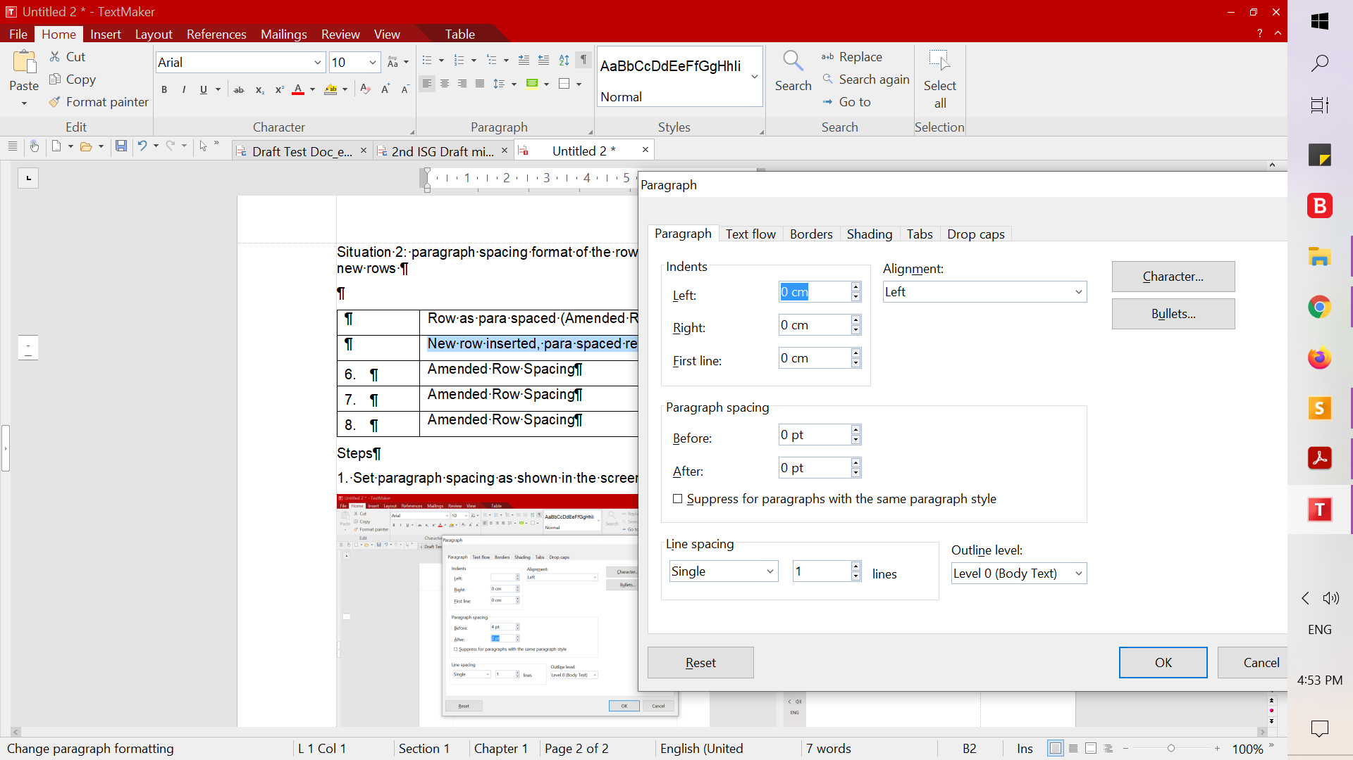
4. But compared to 3rd column which shows the Amended Para Spacing as shown in the screen shot


