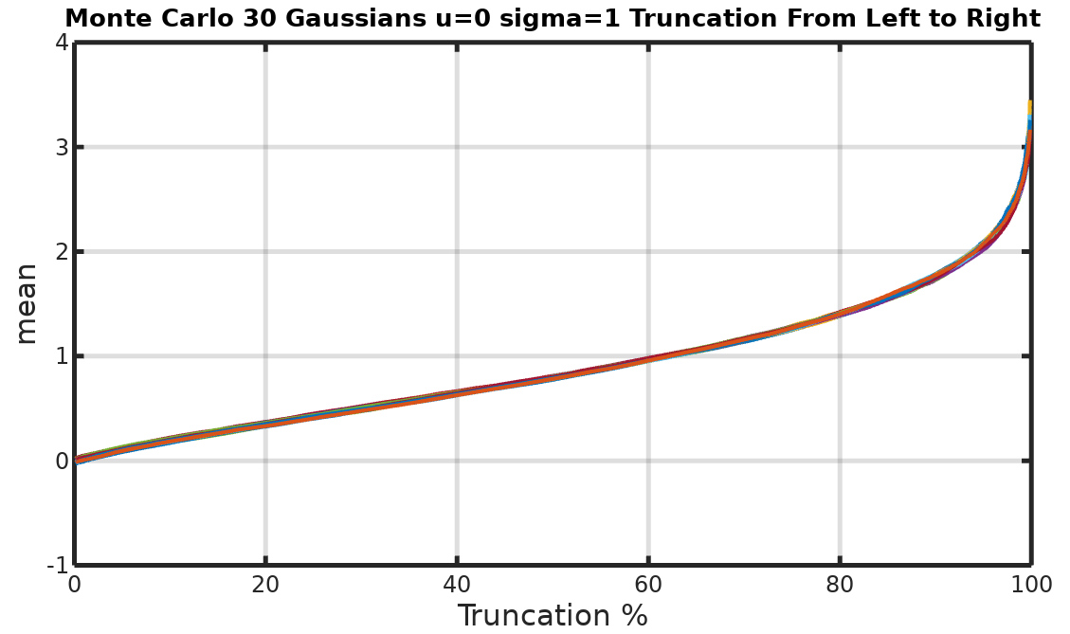
Fig. XX . The mean vs Truncation % - Truncation from left to right

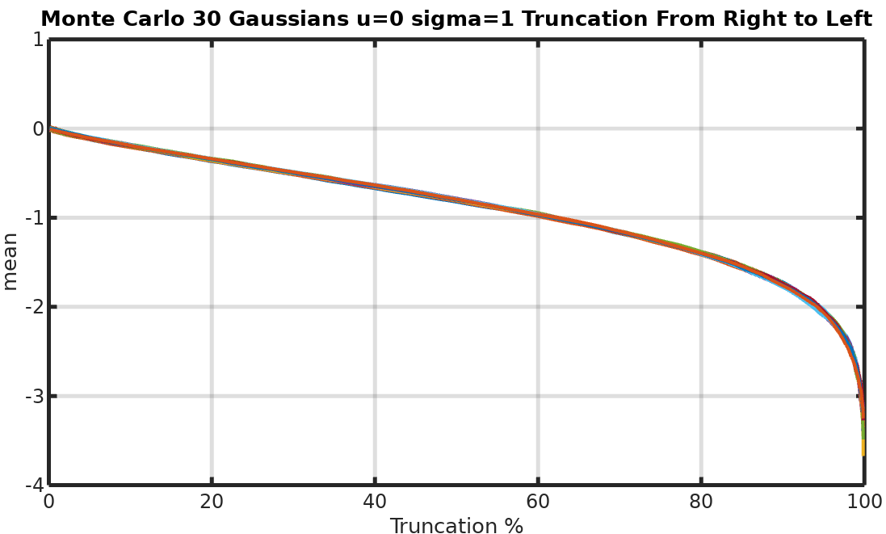
Fig. XX The mean vs Truncation % - Truncation from right to left

