Supplier Shipping Label Standards
Data Area Characteristics (Container Label)
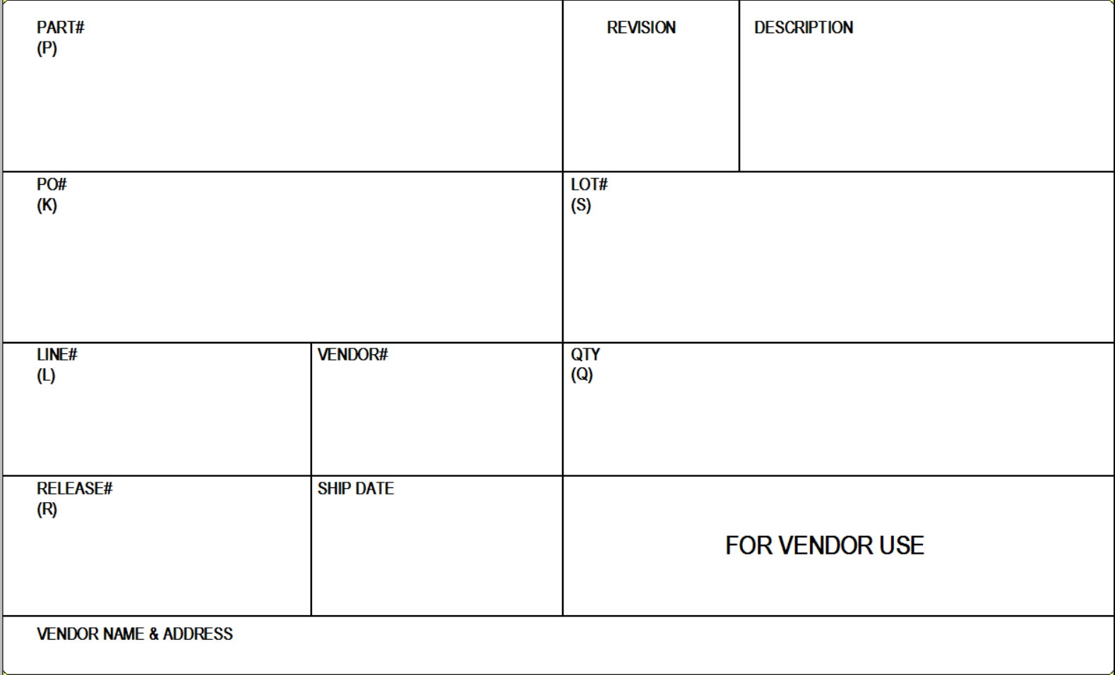
A1
A2
A3
B1
B2
C1
C2
C3
D1
D2
D3
E1

- A1 – Customer Item Part #, Barcode must be prefixed with P
- A2 – Revision Number
- A3 – Item Description
- B1 – Purchase Order #, Barcode must be prefixed with K
- B2 – Lot number, barcode must be prefixed with S. If Serial number is used by supplier and barcode is used, supplier may NOT use S as prefix, another identifier must be used.
- C1 – Purchase Order Line #, Barcode must be prefixed with L
- C2 – Vendor Identification Number
- C3 – Quantity, Barcode must be prefixed with Q
- D1 – Purchase Order Release #, Barcode must be prefixed with R
- D2 – Ship Date
- D3 – Area designated for vendor use. May include barcodes however they may NOT start with the following prefixes: P, K, L, R, S, Q
- E1 – Vendor Name and Address

